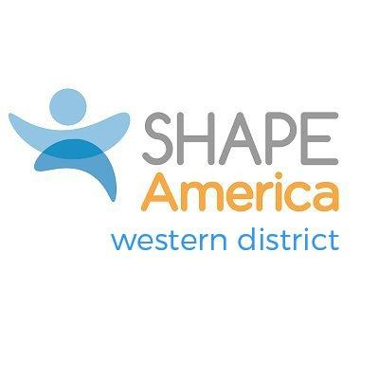
WESTERN DISTRICT HONOR AWARD
Nominations are due by September 15
Applications due October 15
Return to District Awards Chair: See SHAPE America Western District webpage

Any SHAPE America member who resides in the Western District (WD) may nominate candidates for the Honor Award. The Honor Award is the highest recognition the Western District can bestow to an individual who is clearly outstanding in his/her profession with long and distinguished service to health, physical education, adaptive physical education, recreation, dance, and/or sport. The award can be given annually at a WD-sponsored/co-sponsored conference or workshop, or at the state conference of the candidate of each year. The deadline for nominations is September 15 with an application deadline of October 15. The qualifying criterion for this award includes:

- SHAPE America Membership: The nominee shall have been a member of SHAPE America for a minimum of 10 years, including the year he/she is considered for the award. (Former SHAPE America members who have retired from the profession are exempt from this requirement.)

- Character: Ethical behavior consistent with the accepted ideals of the profession.

- Service: Candidates shall display distinctive leadership, meritorious service to the profession, and satisfy five or more of the following conditions. The following are some illustrations of meritorious contributions in the areas of service to the profession, teaching, coaching and/or authorship, research or other creative contributions.
Service to the profession:
- Officeholder in the Western District of SHAPE America;
- Officeholder in the (former) North or Southwest District of SHAPE America;
- Officeholder of a State Affiliate;
- Officeholder of an affiliated organization of SHAPE America or the American School Health Association, or the American College of Sports Medicine;
- Chair of a committee of SHAPE America;
- Chair of a committee of the former North or Southwest District;
- Committee worker over a period of three or more years with a state, district or national organization, either in SHAPE America or affiliated organizations;
- Speaker or clinician before educational groups, at conventions, assemblies, and meetings held in the interest and for the promotion of health, physical education, adaptive physical education, recreation, and dance.

Teaching/Coaching:

- An outstanding contributor to clinics, workshops, and state or local health, physical education, adaptive physical education, recreation, and dance conferences;
- Promoter of outstanding programs in any of the various areas of health, physical education, adaptive physical education, recreation, and/or dance at any educational level;
- An outstanding contributor to the profession whose work has affected its philosophy or practice, not included in the above;
- Demonstrator of outstanding teaching or athletic coaching;
- Recipient of awards for teaching or administration of programs.
Authorship/Research/Creative Contributions:
- Systematic researcher, which has helped to advance the profession;
- Author or co-author of one or more books in health, physical education, adaptive physical education, recreation, dance, and/or sport;
- Author of articles on the subject of health, physical education, adaptive physical education, recreation, and/or dance in magazines of national scope published in monograph form;
- Creator of unique productions in dance, synchronized swimming, etc.;
- Recipient of scholarships, fellowships, grant monies, or monetary awards.

Western District Honor Award
Candidate Application
Applications are due by October 15
Return to District Awards Chair: See SHAPE America Western District webpage

Name of candidate:

School principal/organizational head contact information:

Local media outlet contact information:

Criteria: Membership- Must be a SHAPE America Member for at least 10 years
SHAPE America membership number: __________________

Length of time as a SHAPE America member:____________

Other professional organizational membership(s) or certifications:

- Criteria: Character Provide two letters of support that speak to your character, service, leadership, and contributions to the profession.

- Criteria: Service Provide information of at least five instances that you displayed distinctive leadership, and/or meritorious service to the profession. See the complete list on awards description and criteria page that includes professional service, teaching, coaching, research, or authorship.

Leadership Role:
Organization:
Brief Description:
Dates of Service:
Leadership Role:
Organization:
Brief Description:
Dates of Service:
Leadership Role:
Organization:
Brief Description:
Dates of Service:
Leadership Role:
Organization:
Brief Description:
Dates of Service:
Leadership Role:
Organization:
Brief Description:
Dates of Service:
Leadership Role:
Organization:
Brief Description:
Dates of Service:
Add additional information as needed following the same format as above

